Course Methods test 2 Year 12

Student name: ________________ Teacher name: ________________

Task type: Response

Time allowed for this task: ___40________ mins

Number of questions: ____8_______

Materials required: Calculator with CAS capability (to be provided by the student)

Standard items: Pens (blue/black preferred), pencils (including coloured), sharpener, correction fluid/tape, eraser, ruler, highlighters

Special items: Drawing instruments, templates, notes on one unfolded sheet of
A4 paper, and up to three calculators approved for use in the WACE examinations

Marks available: ___41___ marks

Task weighting: _10___%

Formula sheet provided: Yes

Note: All part questions worth more than 2 marks require working to obtain full marks.

Q1 ( 3 & 3 = 6 marks) (3.2.9)
Determine in terms of for the following. Show all working.
- and when .

Solution
Specific behaviours
anti-diffs terms
introduces an unknown constant and subs to solve
states value of constant

- and when .

Solution
Specific behaviours
anti-diffs terms
introduces an unknown constant and subs to solve
states value of constant

Q2 (3 & 2 = 5 marks) (3.2.22, 3.2.5)
A car travels in a straight line from the origin, initially at rest, with constant acceleration with time in seconds.
- Determine the distance from the origin at seconds?

Solution
Specific behaviours
integrates to find v and shows solving for constant with subs
states the correct rule for x
states exact value for x at required time, no need for units

- What is the velocity of the car at seconds?

Solution
Specific behaviours
subs into v
states velocity, no need for units

Q3 (2 marks) (3.2.19)
Determine the exact area between and the axis from to .

Solution
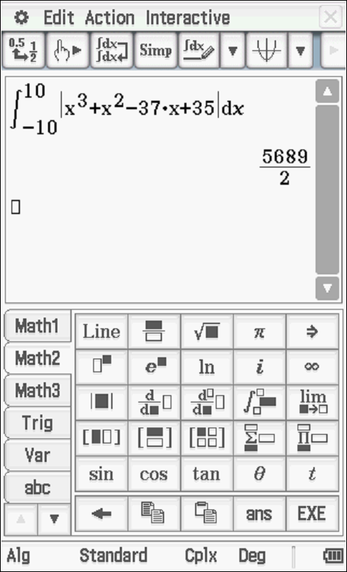

Specific behaviours
writes a correct integral for the area
states exact value

Q4 (2, 2 & 3 = 7 marks) (3.2.18)
A factory produces electric vehicles. The total number, , that the company has produced months after production commenced is such that:
Determine the number produced in
- The first 6 months

Solution
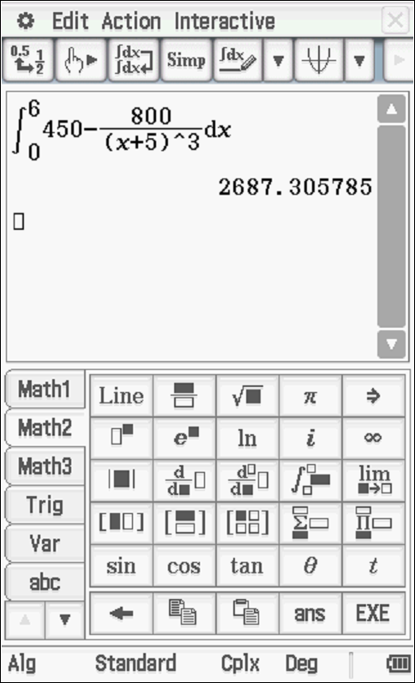
Number is 2687 vehicles

Specific behaviours
writes a correct integral with limits or ant-diff with a constant
states change, accept decimal

- The third month

Solution
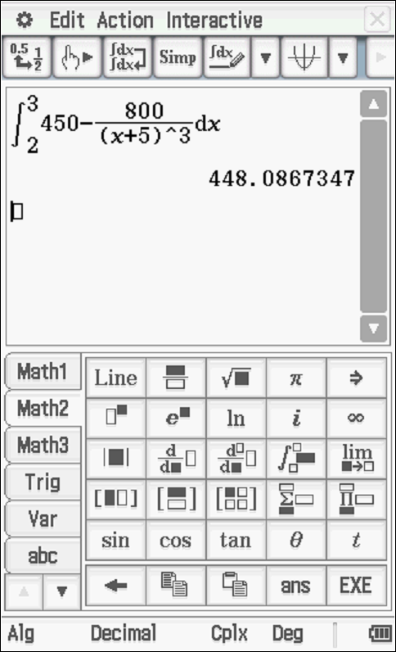

Specific behaviours
writes a correct integral with limits or ant-diff with a constant
states change, accept decimal

Determine the minimum number of months required to produce:
- 10000 vehicles.

Solution
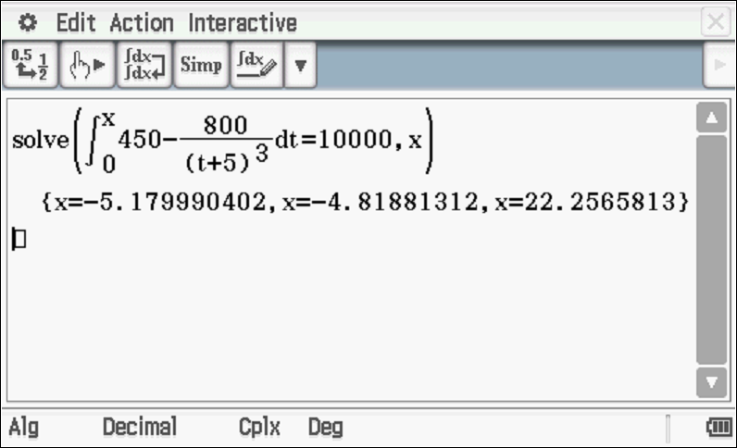

Need at least 22.27 OR 23 months

Specific behaviours
sets up an integral with unknown upper limit
solves for a decimal number of months
states number of months

Q5 (5 & 3 = 8 marks) (3.2.20)
- On the axes below, sketch the following graphs: and . Indicate on your sketch coordinates (one decimal place) of any stationary points and label their nature and of any points where the graphs intersect each other.

Solution
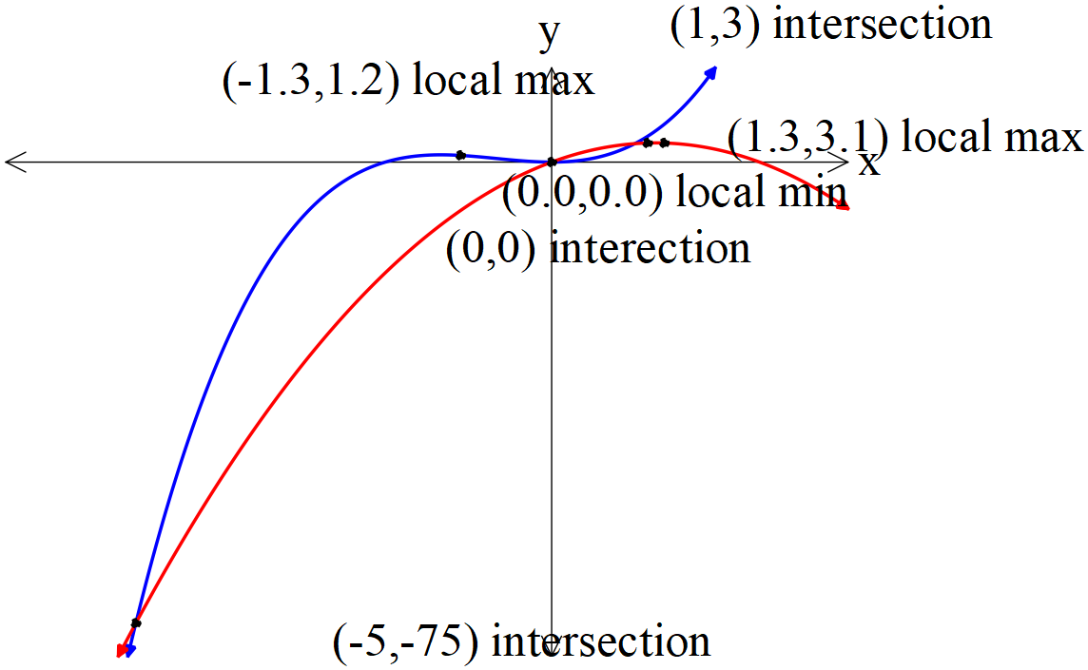

Specific behaviours
states coordinates 1dp local max on both graphs
states coordinates 1 dp local min on cubic (must label min)
shows that graphs intersect at three points
states coordinates of 3 points of intersection
sketches correct shape of both graphs
NOTE: follow through does not apply if mistake makes easier!

- Determine the exact area between and .

Solution
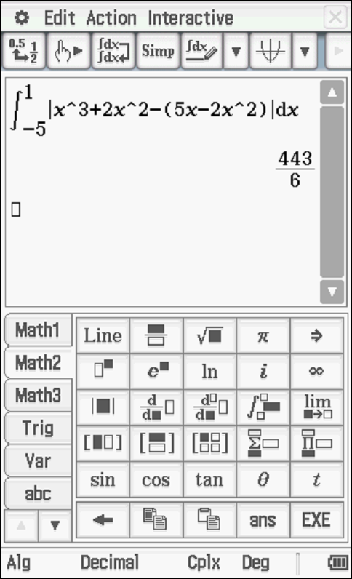

Specific behaviours
sets up correct integral(s)
uses correct limits for integrals
states exact area

Q6 (2 & 2 = 4 marks) (3.1.3, 3.1.4)
The number of kangaroos, in a particular site that have developed disease W are increasing such that with the time in years. There are initially 2300 kangaroos.
- Determine the number of kangaroos with disease W in 5 years’ time.
Solution
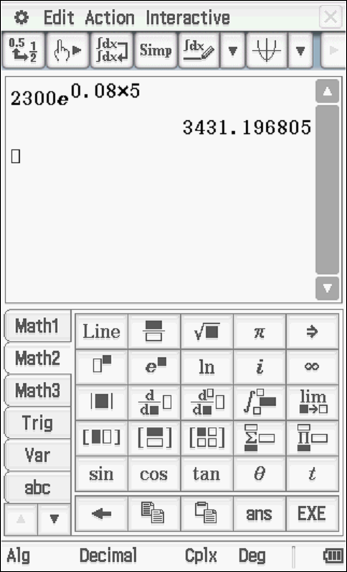

Number of kangaroos 3431

Specific behaviours
uses an exponential function
states number, accept decimal

- Determine the time taken (years in one decimal place) to triple the number with the disease.

Solution
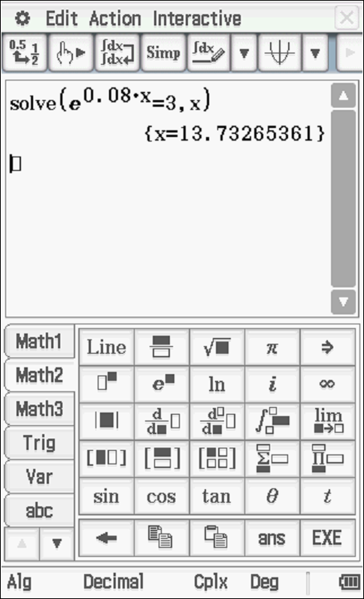

Years = 13.7

Specific behaviours
sets up an equation
states number of years to one decimal place

Q7 (4 marks) (3.2.16)

Consider the function such that and .
Determine the rule for the function .

Solution
Specific behaviours
uses fundamental theorem to express
integrates to express in terms of and a constant
uses definite integral to set up equation for constant
solves for constant and express in terms of x in full.
Q8 (5 marks) (3.1.15)

Consider the function where are constants.

Below is a graph of
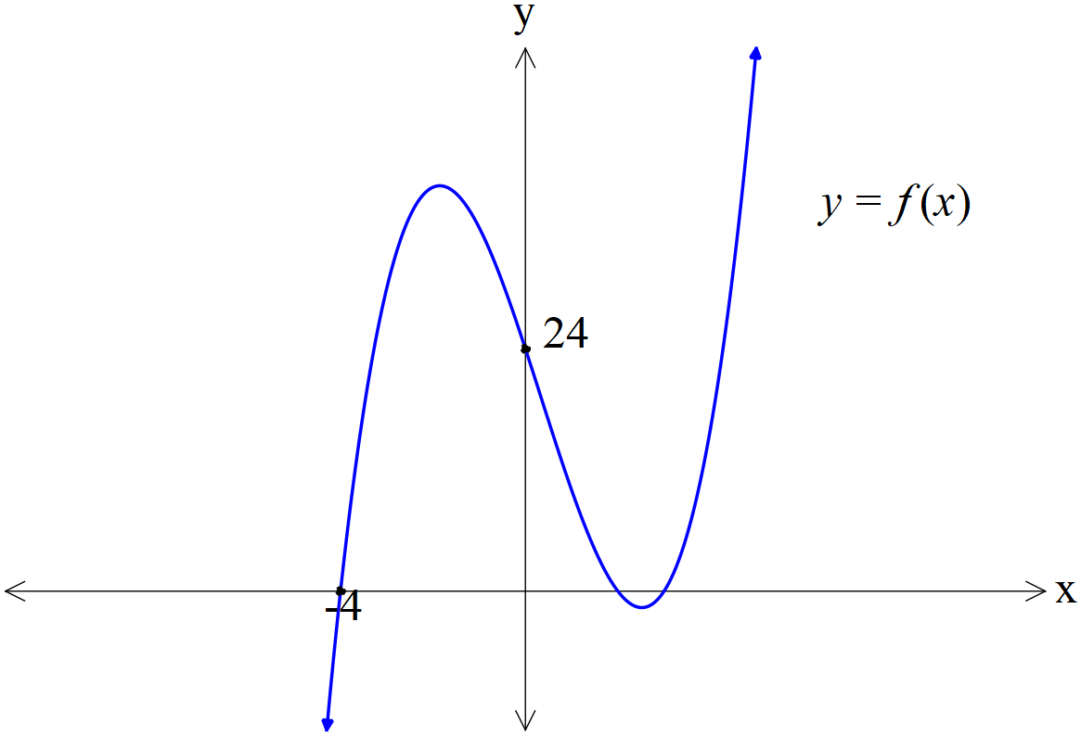

There is an intercept at , intercept at and .
There is an inflection point at .

Determine the exact values of .
Solution
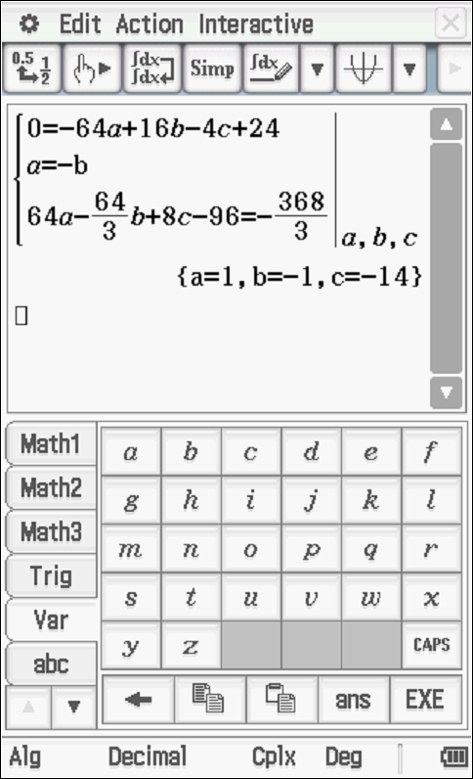
OR solving without classpad
Eq 1 times 2
Specific behaviours
solves for
derives using inflection point
sets up linear equation using x intercept
uses definite integral and then integrates and sets ups a linear equation for unknowns
states values for all 4 unknowns
NOTE: follow through does not apply if mistake makes easier!

